**End of Line (EOL) Test for Motor Module**

**Procedure**

Nikhil Jali  
[nikhil@zeroui.com](mailto:nikhil@zeroui.com)  
ZeroUI

**Setup of Installer:**

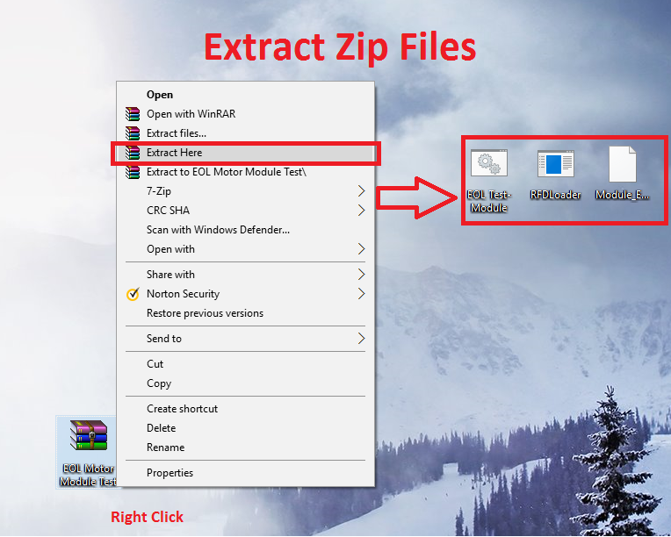

Download the zip file and extract to Desktop. The zip file contains the following files:

1. EOL Test-Module.bat: This is the file used for programming
2. RFDLoader.exe: This is the programming tool
3. Module_EOLTest.hex: This is the file containing the code
4. DeviceMgr.bat: This is the shortcut for debugging and viewing device manager.

There is no more setup. Refer next page for programming the devices

**Programming**

**Step 1: Insert Micro-USB Cable to the Motor Board**

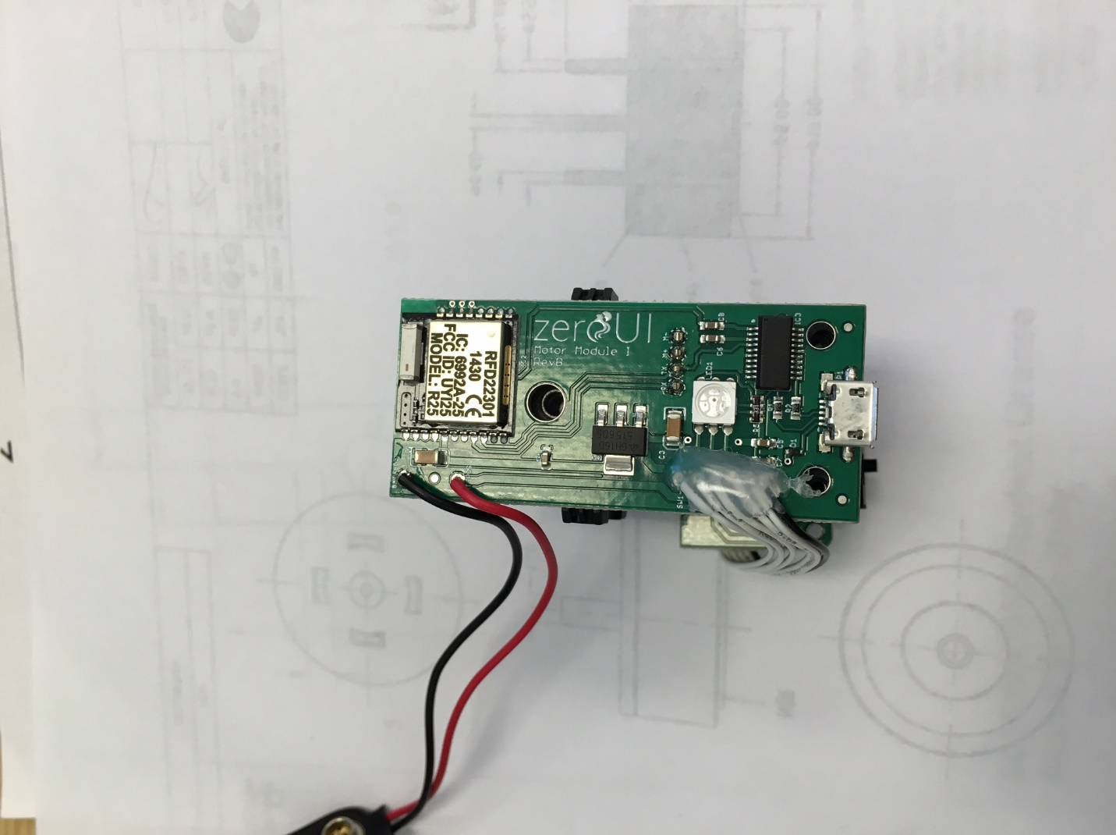 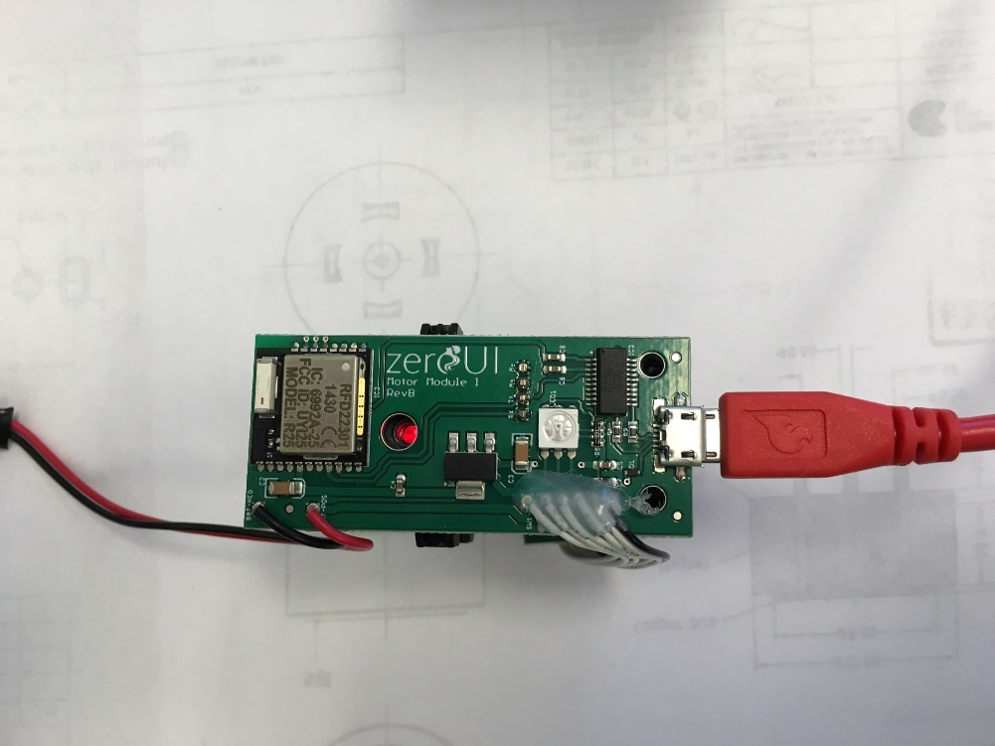

**Step 2: Double Click the EOL Test- Module.bat**

This file is located on the Desktop.   
This opens a command window and starts after 3seconds

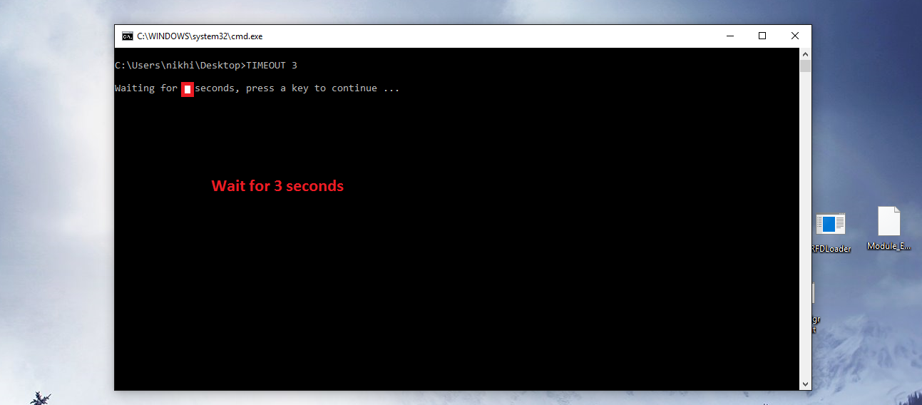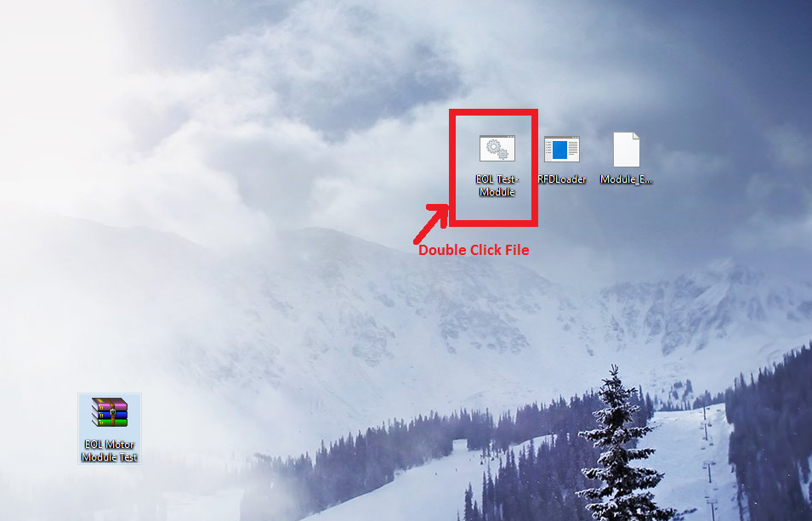

**Step 3: Download of Code is attempted on all COM ports**

Here the board is connected on COM8. Once identified, it begins programming and a “*” status beigins(look at image below)

You will see “fail… fail… fail…” for those ports where board is not connected. (see image below)

Once completed, look for **SUCCESS !**

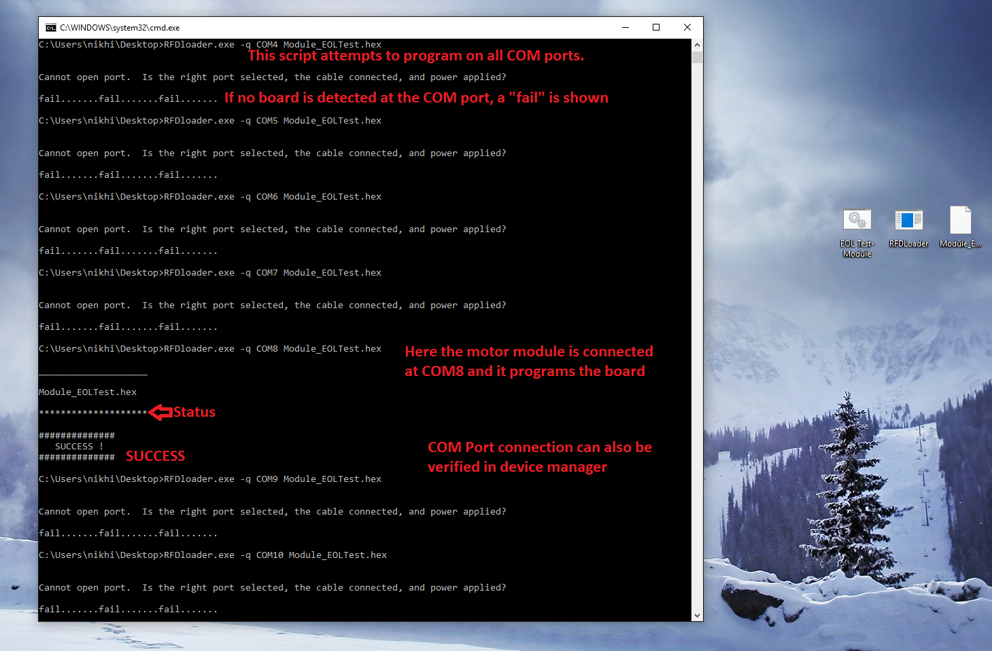

Step 4: On successful test, the LEDs will cycle through various colors and blink blue.

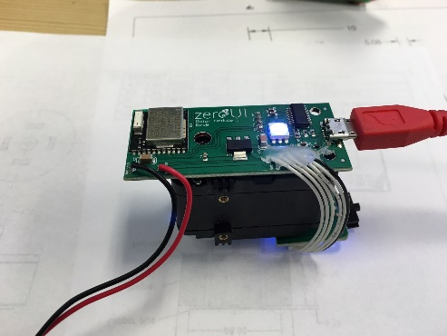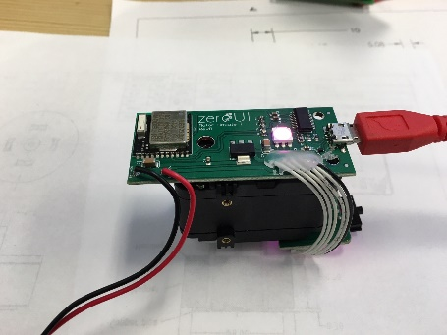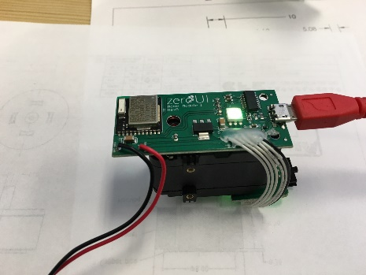

Green

Purple

Blue

TEST PASSED if LEDs Light Up

**Debug Info:**

Double-click **DeviceMgr.bat** from extracted files to see if COM port is connected

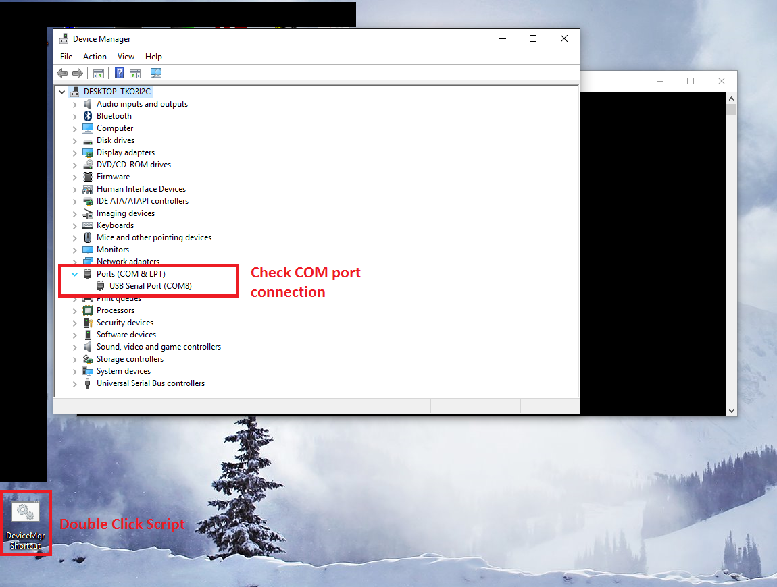

For any other questions call **+1-765-476-3370** or email **nikhil@zeroui.com**